DATE: September 3, 2020

TO: Honorable Mayor and Members of the City Council

FROM: XX, Community and Economic Development Director and
XX, Chief Building Official

SUBJECT: Reach Codes – Proposed Electrification Reach Codes for 2019 Energy Code

RECOMMENDATION
Staff recommends the City Council consider the options of electrification reach codes as written, to be established on January 1, 2021; to help reduce carbon emissions associated with new construction, reduce costs in new construction, improve indoor air quality and safety of our building stock, support affordable housing, and increase adoption of electric vehicles.

BACKGROUND
The <City/Town of XX> has demonstrated leadership in sustainability when <proof that this City has demonstrated leadership in sustainability>.

In alignment with the above, staff recommends modifying Part 6 and Part 11 of the California Building Code. This report provides an overview of the Statewide cost-effectiveness study, details findings, and provides language recommended for the associated reach code for the 2019 building cycle.

Reach Code Adoption Process
Every three years, the State of California adopts new building standards that are organized in Title 24 of the California Code of Regulations, referred to as the California Building Standards Code. This regular update is referred to as a “code cycle.” The previous code cycle was adopted in 2016 and was live on January 1, 2017. The next current code cycle was adopted in 2019 and became effective on January 1, 2020. Cities and counties can adopt reach codes that require items that are above the minimum state code requirements. However, these reach codes must be filed with the State.

In addition, the California Energy Commission (CEC) requires that a cost-effectiveness study be conducted and filed in the case of local amendments to the Energy Code (Title 24, Part 6). It is required that the City demonstrate to the CEC, using a cost-effectiveness study, that the amendments to the code are financially responsible and do not represent an unreasonable burden to the non-residential and residential applicants. A cost-effectiveness study is not required for amendments to the Green Building Code (Title 24, Part 11).

Statewide Cost-Effectiveness Study for Energy Code Reach Codes
Funded by the California investor-owned utilities (IOUs), the California Statewide Codes and Standards Program (Statewide Program) led the development of a cost-effectiveness study for Energy Code reach codes that examined different performance-based approaches for new construction of specific building types. There are two kinds of reach code approaches: performance-based ordinances and prescriptive ordinances. Performance-based ordinances mandate an increase in the overall energy efficiency required but leave flexibility for the builder on how to achieve this goal. In contrast, prescriptive ordinances mandate implementation of a specific measure (such as solar panels or cool roofs). The Statewide Program’s analysis focused on performance-based ordinances but some conclusions about prescriptive measures can be made from the results.

Building Prototypes
The Statewide Program’s analysis estimated cost-effectiveness of several building prototypes including one-story and two-story single-family homes, a two-story and five-story multifamily building, a three-story office building, a one-story retail building, and a four-story hotel. The single-family homes, multifamily homes, and office building prototypes are directly applicable to <City/Town Name> development. The City has averaged <number of single-family homes permitted year> new single-family homes constructed each year over the past five years. Additionally, many approved development projects include <type of non-res buildings most commonly permitted>.

Building appliance electrification options in California can generally be broken into three categories:
- Natural Gas Ban: No gas hookup allowed (via municipal ordinance).
- All-Electric Required: Appliances must be electric (via Energy Code, Title 24 Part 6).
- All-Electric Preferred: Allows mixed-fuel buildings with high energy performance, requiring additional energy efficiency measures, battery storage, and/or pre-wiring for buildings to be electric-ready.

Electric Vehicle Charging Infrastructure
Electric Vehicle (EV) charging requirements in California can generally be broken into three categories:
- EV Charging Installed: All supply equipment is installed at a parking space, such that an EV can charge without additional equipment.
- EV Ready: Parking space is provided with all power supply and associated outlet, such that a charging station can be plugged in and a vehicle can charge.
- EV Capable: Conduit is installed to parking space, and building electrical system has ample capacity to serve future load. An electrician would be required to complete the circuit before charging is possible.

EV charging capacity and speed can be summarized as three categories:
- Level 1: Capable of charging at 120V, 20A. This is an equivalent to a standard home outlet.
- Level 2: Capable of charging at 240V, 30-40A. This is the service capacity typically used for larger appliance loads in homes
- Level 3 (DC Fast Charging): Capable of charging at 20-400kW. This is the type of charger used for Tesla Superchargers and DC Fast Chargers at some supermarkets.

The 2019 California Green Building Code Update (Title 24, Part 11) increases requirements for electric vehicle charging infrastructure in new construction; including:
- New one- and two-family dwellings and townhouses with attached private garages: must be Level 2 EV-capable
- Multi-family dwellings: 10% of parking spaces must be Level 2 EV-capable
- Non-residential: 6% of parking spaces must be Level 2 EV-capable

DISCUSSION

Building Appliance Electrification
Each option for building electrification has unique benefits and demerits. Several cities, including the cities of Berkeley, Morgan Hill, and San Jose, have adopted (and are continuing to adopt) ordinances known as natural gas prohibitions, that are more aggressive than the all-electric and electric-preferred model reach codes. These natural gas bans eliminate the use of natural gas infrastructure and result in significant decreases in greenhouse gas emissions. However, natural gas bans often receive more opposition from residents and other stakeholders and are more difficult to implement.

The all-electric required model requires specific end-uses to install electric appliances, with exceptions. For multiple reasons including health, safety, economics, and environmental benefits, there is considerable interest in mandating all-electric new construction, or “building electrification,” which means that the buildings would not have any fossil fuel services. All-electric buildings have electric appliances for space heating, water heating, clothes-drying, and cooking. The interest in building electrification stems from the fact that <Peninsula Clean Energy or Silicon Valley Clean Energy> is providing <90% (if PCE) 100% (if SVCE)> carbon-free electricity and eliminating the use of natural gas can greatly reduce greenhouse gas emissions from the building sector.

The all-electric preferred approach encourages electrification by giving builders the choice of two options:
- achieving a higher energy efficiency level than the Energy Code using mixed fuels (natural gas and electricity); or
- building an all-electric building at the minimum efficiency as required in the Energy Code. The Statewide Program’s study analyzed this approach.
The all-electric preferred model requires buildings to perform at a higher level when natural gas is installed to any end-use. Out of the three models, this model allows building designers and developers the greatest flexibility in building design. However, the allowance of gas infrastructure limits cost savings and greenhouse gas emissions savings that can be gained from this option.

Below is a table of ordinances that have been adopted by San Mateo and Santa Clara County jurisdictions:

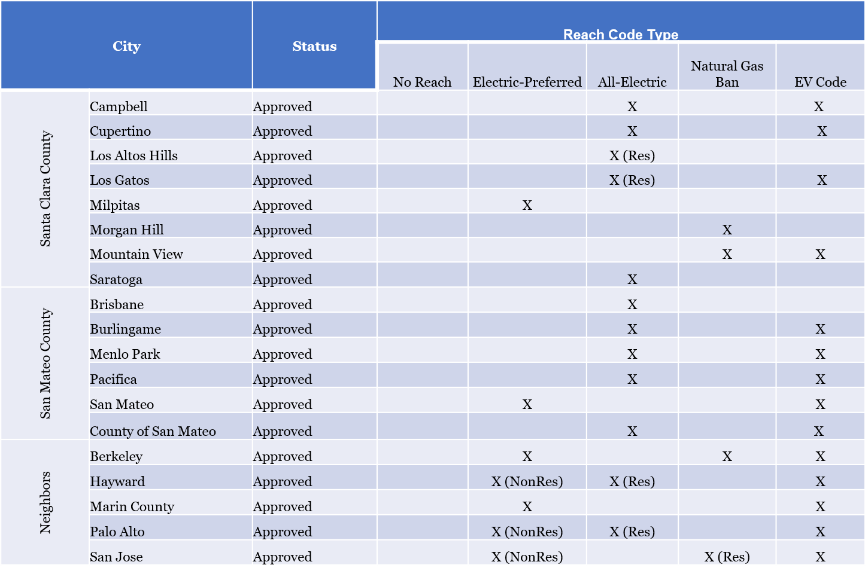

Electric Vehicle Charging Infrastructure
Local residents are showing a significant interest in electric vehicles. For example, the number of registered plug-in vehicles in <San Mateo County increased by 36% in 2018. By comparison, registrations for vehicles powered by fossil fuels grew by only 2% that year. > <Santa Clara county increased by 31% in 2018 By comparison, registrations for vehicles powered by fossil fuels shrank in 2018.> It is widely known that availability of EV charging infrastructure is a critical component to EV adoption. Meanwhile, it is significantly more expensive to install charging infrastructure as a retrofit than it is during new construction. As such, ensuring that newly constructed residential and non-residential parking has ample EV charging capability will reduce long-term costs of EV infrastructure installation, while helping to increase EV adoption and decrease transportation-related greenhouse gas emissions. While California’s new minimum requirements are a step forward, it is unlikely that the requirements for multi-family dwellings and non-residential buildings are enough to keep pace with expected EV growth looking towards 2030. The Statewide Program’s team reviewed approaches to increase the amount of EV infrastructure in new construction buildings, while keeping construction costs as low as possible.

FINDINGS
Building Appliance Electrification Reach Codes:
Staff have worked closely with PCE/SVCE’s consultants to interpret the study’s results and infer what options may or may not be cost-effective for the building types that are prevalent in <City/Town Name> but were not analyzed by the team. Peninsula Clean Energy and Silicon Valley Clean Energy have also provided consultant support to assist cities in understanding the cost-effectiveness study results and adopting reach codes. The proposed reach codes meet the requirements of the CEC for cost-effectiveness and are also a cost-effective approach for constituents, contractors, and developers pursuing new construction within city limits. In addition, the results of the analysis show that all-electric buildings are typically less expensive to construct.

Recommended reach code requirements for newly constructed buildings are:

- Require new buildings to be all-electric with exceptions
- Require all exempted appliances have electrical pre-wiring to accommodate a future electric appliance
- Require 3kW solar photovoltaic system on new non-residential buildings with less than 10,000 square feet of gross floor area, and 5kW solar photovoltaic system for non-residential buildings with greater than 10,000 square feet of gross floor area

Electric Vehicle Charging Infrastructure Reach Codes
Unlike amendments to the Energy Code, a cost-effectiveness study is not required for amendments to Title 24, Part 11, or the Green Building Code “CALGreen” which covers items such as electric vehicle (EV) charging infrastructure. However, to evaluate the financial impact on first costs, PCE/SVCE commissioned an analysis of the total cost of implementing various EV infrastructure measures. Staff have worked closely with Peninsula Clean Energy, Silicon Valley Clean Energy, and the Statewide Program’s team to establish new construction EV requirements which are more in-line with local EV adoption trends, while providing flexibility for the builder and keeping construction costs as low as possible.

Recommended requirements for EV infrastructure are:

Residential
- Single Family Dwelling: One dedicated “plug and play” Level 1 circuit, and one dedicated “plug and play” Level 2 EV circuit.
- Multi-Unit Dwelling, <20 units: Per unit, a single “plug and play” Level 2 EV circuit
  - Exception: Not required for units without parking
- Multi-Unit Dwelling, >20 units: 75% of the units, a single “plug and play” Level 1 EV circuit; 25% of the units, a single “plug and play” Level 2 EV circuit
  - Exception: Not required for units without parking
“Plug and play” is defined as a full circuit installed including capacity to deliver electricity and outlet.

Non-Residential Office
- 10% of the parking spaces, Level 2 EV charging infrastructure installed
- 10% of the parking spaces, “plug and play” Level 1 EV circuits
- 30% of the parking spaces EV capable at the pinch points utilizing at least Level 2-sized conduit with panel capacity for 2kW per EV capable parking space

Non-Residential, Non-Office
- 6% of the parking spaces, Level 2 EV charging infrastructure installed
- 5% of the parking spaces, “plug and play” Level 1 EV circuits
- For parking lots with over 100 spaces, first hundred spaces must adhere to Level 1 & Level 2 requirements, with option to substitute 80kW DC fast charger for subsequent sets of 100 spaces.

Ordinance Language
Full text of recommended ordinances is available in corresponding document titled <ordinance document title>

STAFF CONTACT <staff contact name>
<contact email address>; <contact phone number>

FISCAL IMPACT:

No significant fiscal impact.

ENVIRONMENTAL CLEARANCE:
In accordance with CEQA Guidelines section 15378(b)(5), action on this item is not a project subject to CEQA because policy direction is an administrative action that will not result in a physical change to the environment.

ALTERNATIVES:

- Adopt only the State model codes without adopting any local amendments at this time.
- Direct staff to revise or remove specific local amendments.
- Request staff to bring back additional information for further consideration.

RECOMMENDATION:

Waive First Reading, and to Introduce the Reach Code Ordinance to be Adopted by Reference, to Schedule Public Hearing to Waive the Second Reading for Adoption and Adopt Resolution Approving Findings of Necessity and Need for Amendments, Deletions and Additions to the City/Town Name Municipal Codes.

DISTRIBUTION:

California Building Standards Commission

ATTACHMENTS:

- Resolution
- Cost-effectiveness findings

DATE PREPARED:
September 3, 2020

